**AWS Task-4**

**Task Description:**

Launch an EC2 instance (Linux and Windows) along with a web server. Then, create an EBS volume of 5 GB, attach it to an EC2 machine (Linux and Windows), and take a snapshot. Finally, create an EBS volume using the taken snapshot.

Windows EC2 with web server: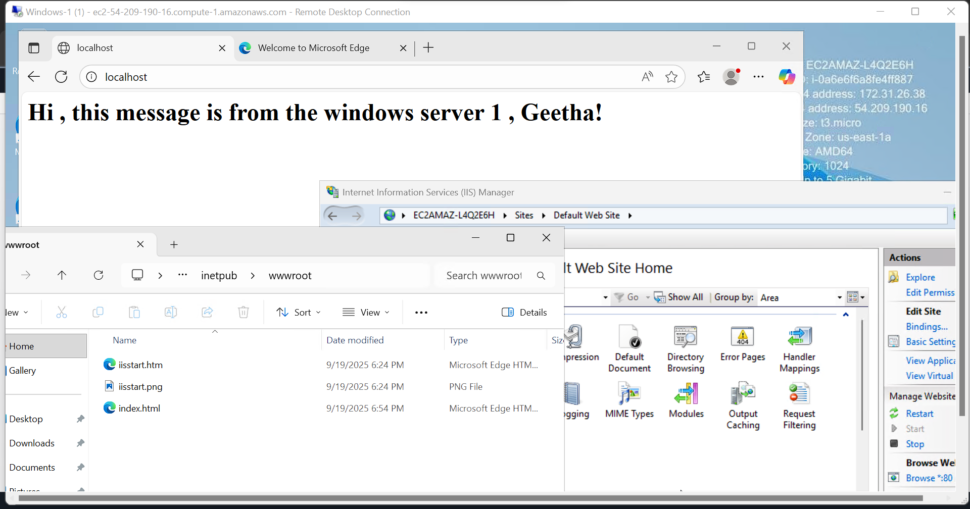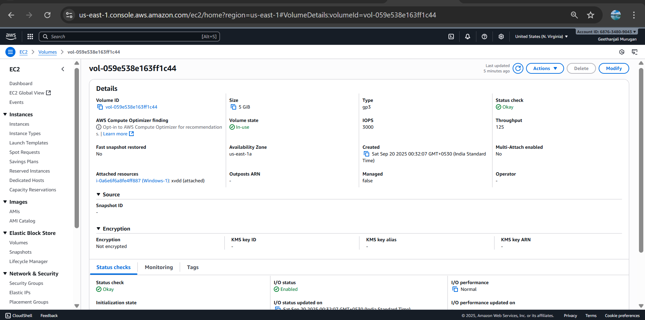

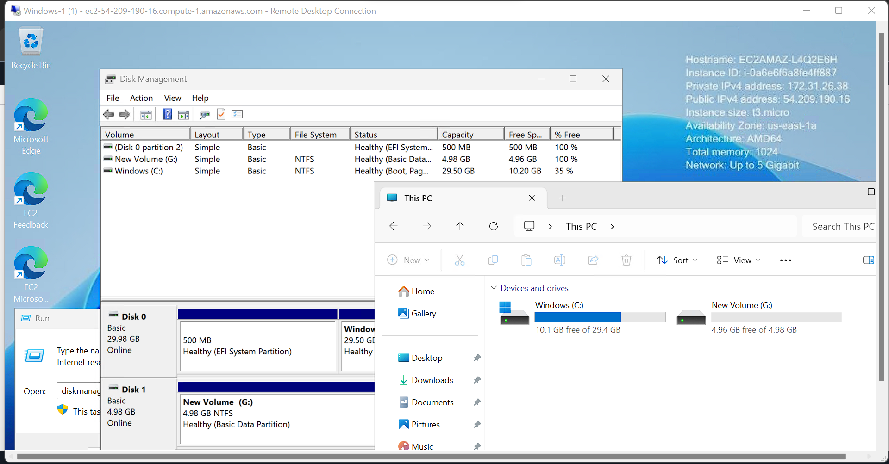

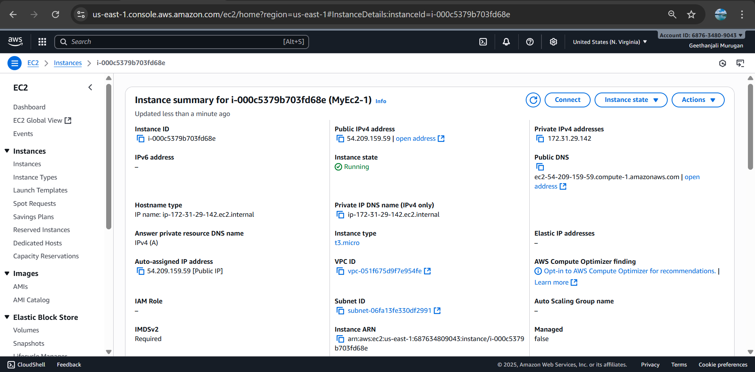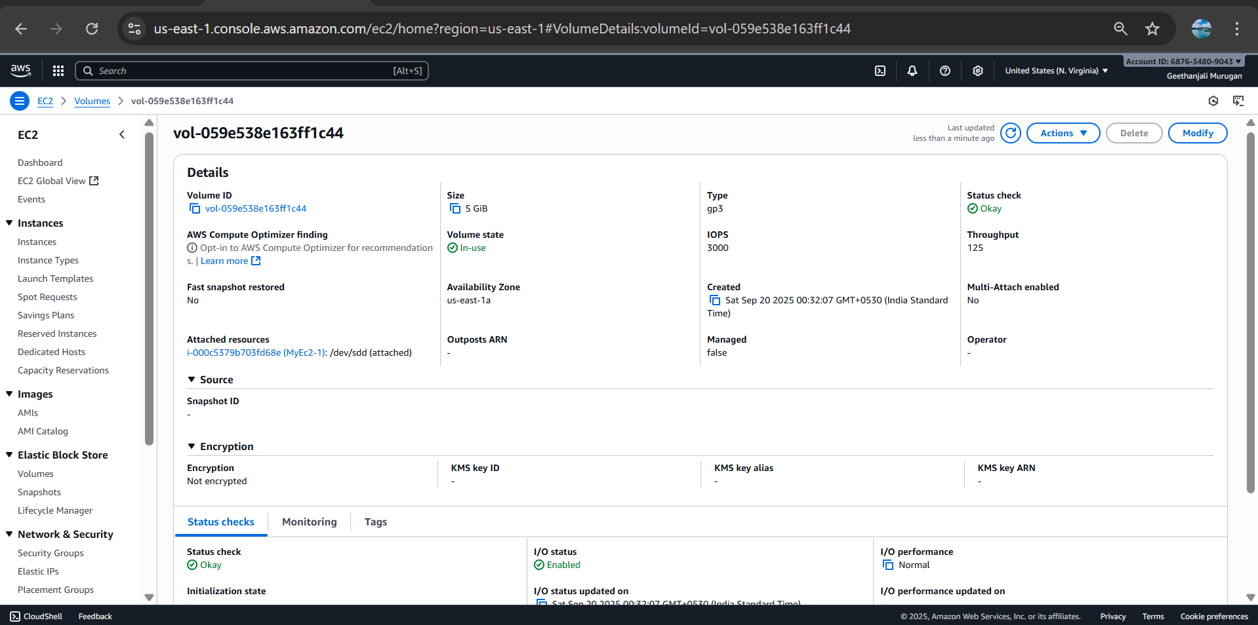

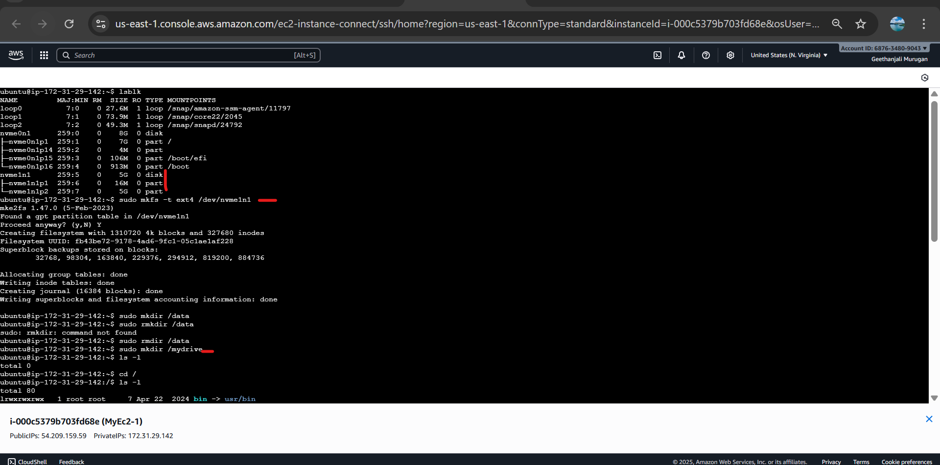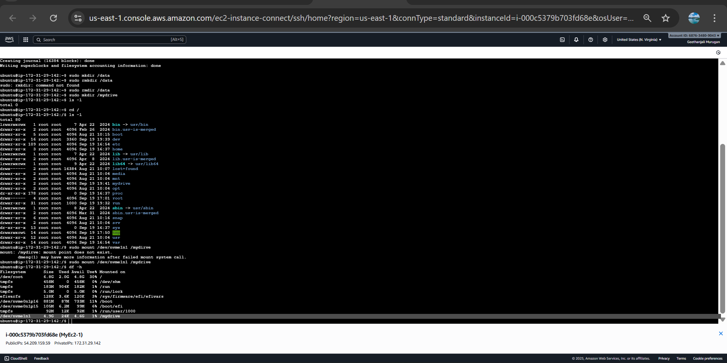

Snapshot created: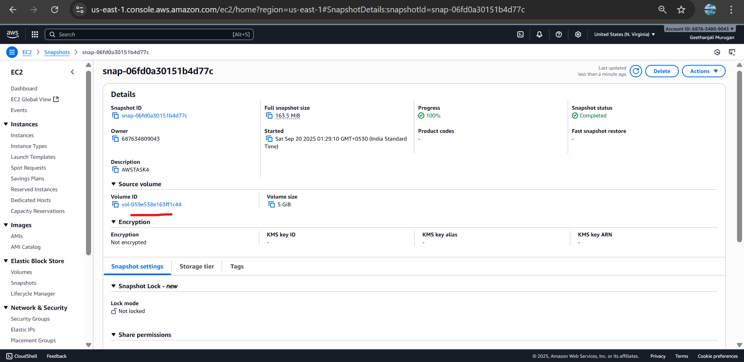

Created a volume with 8 GB from the snapshot above and assigned to a new EC2 linux instance